PHYSICS f4
PAPER 1
MARKING KEY
Section A (70 marks)
- a. Give two examples of systematic error
- zero error
- calibration error
(2 marks)
b. State the kinetic theory of matter
- its states that matter is made up of tiny particles that are in constant random motion (1 mark)
c. figure 1 below is a measuring instrument
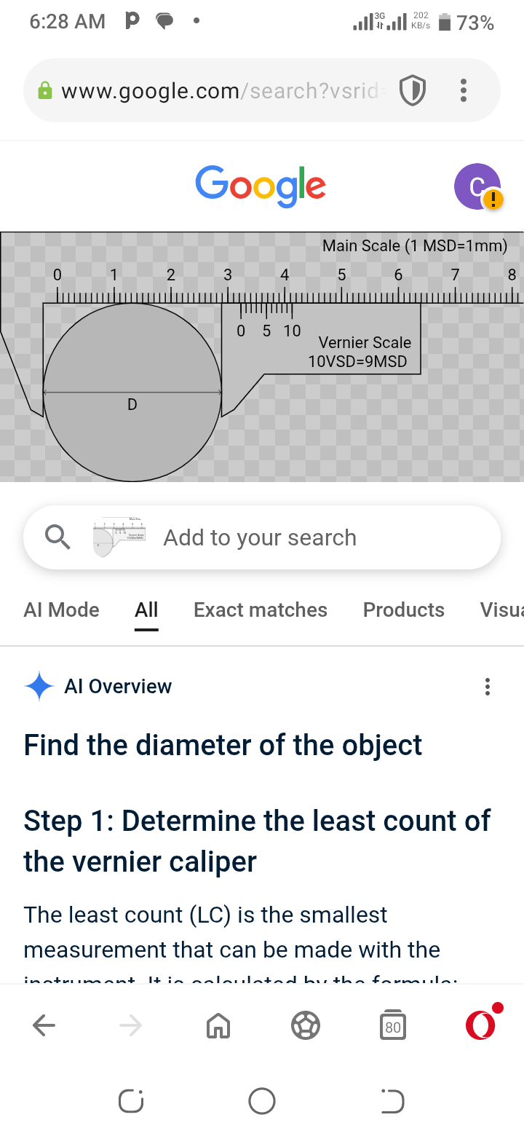

- What is the advantage of using this instrument
- It is used to measure small lengths (short distances)
(1 mark)
- Calculate the size of the object being measured on the instrument
MSR + (VC x LC) = 3 + (3 x 0.01) 1 mark
=3.2 + 0.03 (1 mark)
=3.23 cm (1 mark)

(3 marks)
- a. i. – the materials used in tooth filling needs to have same coefficient of expansion as the tooth (1). As the tooth expands the material expands as well.(1)
ii. – two metal plates can be fixed together by means of a hot rivet(1) and then
hammered so that as it cools the plates are tightly held together.(1)

b. Derive the formula F = ma
Force = rate of change in momentum 1 mark
Force = Mv – Mu
t
Force = m (v – u)
t
But Acceleration (a) = v – u 1 mark
t
Therefore, Force = mass x acceleration
F = m x a 1 mark
(3 marks)
- a. The figure below is a Light wave passing through two gaps on a barrier
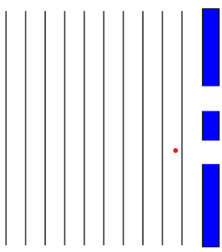

- On the same diagram, complete the wave to show how the wave is going to emerge on the other side of the diagram
(2 marks)
- What two properties of waves is shown on the completed diagram.
- Interference I mark
- Diffraction 1 mark
b.
I. $V.R = 5$
$Load = mg = 30*10 = 300$N
$$M.A. =\frac{Load}{Effort}1$$
$$= 300N/60N$$
$$= 5$$
$$E = M.A./V.R. *100\%$$
$$= 5/5 *100$$
$$= 100\%$$
- a. Differentiate between speed and velocity
- Velocity is a vector quantity while speed is a scalar quantity (1 mark)
b. $m_{1}u_{1}+ m_{2}u_{2}=v(m_{1}+ m_{2})$ 1
25kg*10m/s + 7kg*6m/s = $v$ (25kg + 7kg) 1
208kgm/s = 32kg $v$
$v=65m/s$ 1
c. – Gas particles are far apart and in constant random motion as such aroma
from the kitchen is able to flow in all directions including the sitting room.
- a. Hooke’s law states that provided the elastic limit is not exceeded, the extension of the spring is directly proportional to the load applied on the spring. (1 mark)

b. i. – parallel spring combination
ii. $KP = nk$
$$KP = 2*2N/m$$
$$KP = 4N/m$$
$$e = F/k$$
$$e = 600N/4N/m$$
$$e = 150N/m$$

(4 marks)
c. Give one differences between heat and temperature
- Heat is measured in joules while temperature is measured in Kelvin
- Heat is a form of energy that is transferred from a body of higher temperature to a body of lower temperature
- Heat is measure by a colorimeter while temperature is measured by a thermometer (1 mark each for any )
- a. Define pressure
- Pressure is force acting per unit area (1 mark)
b. Calculate the pressure exerted by a column of a liquid at the base of a container if the density of a liquid is 13600 kg/m³ and its depth is 0.1 m. (g = 10 m/s²).
Pressure = dgh 1 mark
Pressure = 13600 x 10 x 0.1 1 mark
Pressure = 13600 Pa 1 mark

- marks)

c. Calculate the speed of an object during the first 1 hour
Speed = Distance / time 1 mark
Speed = 10 km / 1 hour 1 mark
Speed = 10 km/h 1 mark

(3 marks)

- a. i. - inflates/ expands
ii. - increase in temperature makes molecules gain more kinetic energy and move faster¹. The molecules collide with each other and the walls of the container more vigorously¹. Which increases pressure¹. The molecules exert more pressure on the walls of the container and the balloon. The balloon expands¹.
b. Give two advantages of using alcohol thermometer over mercury thermometer.
- Has a very low freezing point of 112 ⁰C hence its suitable in thermometer to record very low temperatures.
- Can be coloured brightly by adding dye that makes it clearly visible through the glass.
- Has uniform expansion and contraction than even mercury.
- Is good thermal conductor, cheap and easily available.
(2 marks)
- a. State Boyles law
- It states that the volume of a fixed mass of gas is inversely proportional to the pressure provided temperature remains constant (1 mark)
b. A tyre has a volume of 0.055 m³ and contains air at a pressure of 145 Pa and a temperature of 280K. What temperature does the tyre have if its pressure is to be increased to 196 Pa assuming the volume of the tyre has increased to 0.52 m³?
P1 x V1 = P2 x V2
T1 T2
145 x 0.055 = 196 x 0.52
280 T2
T2 = 196 x 0.52 x 280
145 x 0.055
T2 = 3578.38 Kto 2 dp 3

- marks)

c. – momentum before collision equals to momentum after collision.
- Total momentum of bodies before collision is equal to the total momentum after collision.
d . – banking of roads,
- centrifuge

- a. The figure below is a diagram of a color code resistor
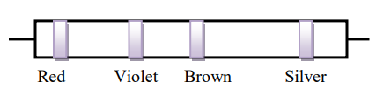

- Find the resistance of the resistor
2 7 0 10%
= 270 Ω ⁺₋10%

(3 marks)
b. An electrical heater is rated at 200 W. If electrical energy costs K28.00 per kWh,
what is the cost of using this heater for 8 hours at its maximum power?
Energy = Power x time
= 200w/1000 x 8
= 0.2 Kwh
Cost = energy x cost per kwh
Cost = 0.2kwh x K28.00/kwh
Cost = K5.6

(4 marks)
- a. State Newtons third law of motion
- it states that whenever a body exerts a force another body, that other body exerts an equal but opposite force on the first body / for every action, there is an equal but opposite reaction
(1 mark)
b. Explain how swimming is made possible
- a person pushes water backward¹, the water reacts by pushing a person forward¹ hence a person swim in water¹
(3 marks)
b. Calculate the work done if an object of mass 20kg is lifted 10m
Work = weight x height
Work = (20 kg x 10 N/kg) x 10m
2000 j

(3 marks)

SECTION B (30 MARKS)
- a. Figure below is a graph showing behavior of water as temperature changes.
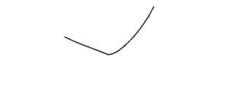
volume
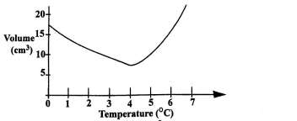
density

- Explain how this behavior of water make the survival of aquatic life possible when water freezes in the lake
- As the temperature of air above the lake falls from 7 ⁰Cto 4 ⁰C, the density of water increases¹. This denser water at the top sinks to the bottom of the lake¹ and remains there in liquid form¹. The water on the top freezes to ice at 0 ⁰C and floats¹. The fish and other aquatic animals and plants survives in the liquid water at 4 ⁰C below the ice during the cold weather¹.
(5 marks)
b. Explain how a falling object in air reaches terminal velocity
- When a body is falling through air only two forces act on it¹. These forces are air resistance and gravitational force¹. When a body has just been released, weight increases than air resistance (W>Fr)¹. As it accelerates downwards air resistance starts to increase¹. When air resistance equals the pull of gravity (Weight) then a body reaches terminal velocity (W = Fr)¹. A body falls at this velocity until it reaches the ground.
(5 marks)
- a. With the aid of a labelled diagram, describe how a liquid in a glass thermometer work

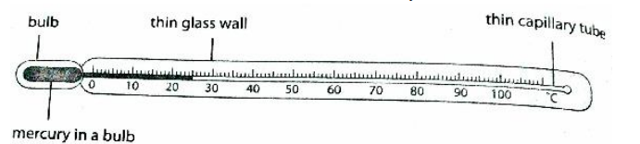

1 mark for correct drawing
1 mark for any two correct labeling
- When the liquid in glass thermometer has come in contact with the body to be
measured, the heat reaches the walled bulb hence thermometric substance inside
expands¹ following the capillary tube to attain the temperature of the surrounding¹.
This gives the temperature of the surrounding¹. When temperature decreases the
thermometric substance contracts¹ and gives the temperature of the surrounding¹.
(7 marks)
b. Explain why dams are constructed thicker at the bottom
- Liquid pressure increases with depth¹, dams are constructed thicker at the bottom so that it withstands the high pressure of water at the bottom¹ hence preventing breaking of the dam¹. (3 marks)

- a. with the aid of the diagram, describe how a destructive interference of waves occurs in water wave.
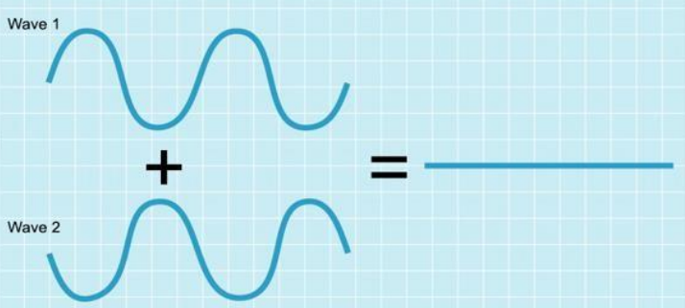

1 mark for waves out of phase
1 mark for resultant wave
- Destructive interference is caused when two identical waves move in opposite directions¹. When the waves meet, the crest of one wave coincides with the trough of the other wave, while the trough of the other wave coincides with the crest of the other wave¹. The waves are out of phase by 180°.
(5 marks)
b. Design an experiment which could be used to find the speed of sound in air using an
echo.
1. Measure a distance of 100 m from the high wall by using a measuring tape¹.
2. Stand at a distance of 100 m (point A) from the high wall (point B)¹.
3. Fire a toy gun at point A. Start the stopwatch as soon as you fire a toy gun¹. Stop the stop watch as soon as you hear an echo. Record the time taken from the time the gun was fired to the time an echo was heard¹.
4. use the formula below to find speed
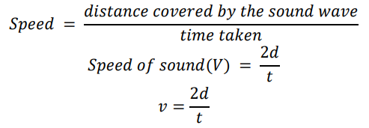

1 mark
END (5 marks)

